Compulsory Assignment 1

Question 1.

a)

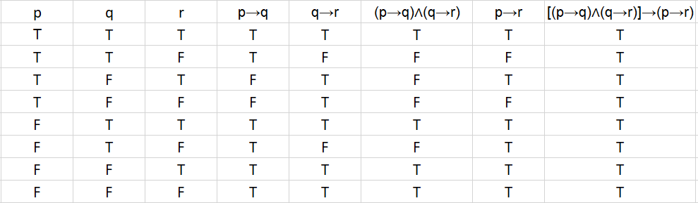

b)

We can see by the truth table above, that the answer to the compound proposition is true regardless of the values of p, q, and r. Therefore, it is a tautology.

c)

For this exercise we will prove the logical equivalence between (p∧¬q)→r and p→(q∨r), (marked in grey), using truth tables.

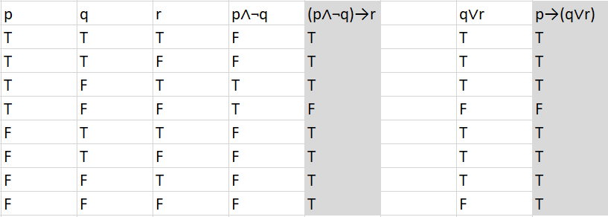

d)

The truth value for (∀n∃m(n+m=0)) statement is true. The reason why is if you have a number n you can find the opposite m to make n + m = 0. To give an example if you have n = -1 then your m will be -(-1), and -1 + (-(-1)) = 0.

For the other statement, (∃n∀m(n<m2)), despite what we choose m to be, it will always be positive because we square it. That means we can choose n to be -1 and the statement will always be true.

Question 2.

Prove that if *m* and *n* are integers and *mn* is even, the *nm* is even, or *n* is even.

First, we will look at what happens when both m and n is an odd number. Assume that *m = 2k+1* and n = 2i+1, where k and i are in the domain of **Z**.   
mn = (2k+1)*(2i+1)   
= 4ki+2(k+i)+1   
= 2(2ki+k+i)+1  
  
Since both k and i are just integers we can write (2ki+k+i) as r. Which makes   
mn, = (2r+1), an odd number when both m and n are odd.

When we look at an instance where one of them is even, we will get the following:  
  
Assume that m = 2k+1 and n = 2i, where both k and i are in the domain of **Z**.  
mn = (2k+1)*(2i)  
= 2(2ki+i)  
  
Since both k and i are just integers we can write 2(2ki+i) as r. Which makes  
mn, = 2r, an even number when either m or n is an even number.  
  
Finally, when we have two even numbers, we will get the following equations:  
  
Assume that m = 2k and n = 2i, where both k and i are in the domain of **Z**.  
mn = (2k)*(2i)  
= 4ki  
  
Since both k and i are just integers we can write (ki) as r. Which makes  
mn, = 2r, an even number when both m and n are even numbers.  
  
This proves the original question that mn is even when both of them or one of them is even.

Question 3.

a)

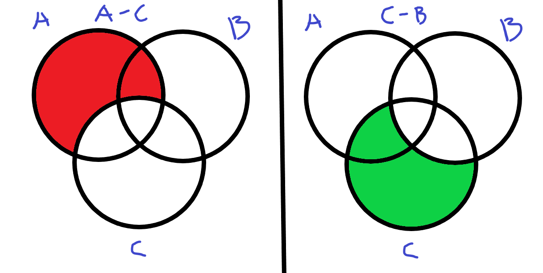 $$\left(A-C\right)=\left\{x | x∈A∧x∉C\right\} \\ \left(C-B\right)=\left\{x | x∈C∧x∉B\right\} \\ \left(A-C\right)∩\left(C-B\right) \\ \left(x∈A∧x∉C\right)∧\left(x∈C∧x∉B\right) \\ \left(x∈A∧x∈\overline{C}\right)∧\left(x∈C∧x∈\overline{B}\right) \\ \left(x∈A∧x∈\overline{B}\right)∧\left(x∈C∧x∈\overline{C}\right) \\ \left(x∈A∧x∈\overline{B}\right)∧\left(∅\right) \\ (∅)$$

This proves that $\left(A-C\right)∩\left(C-B\right)$, is an empty set

b)

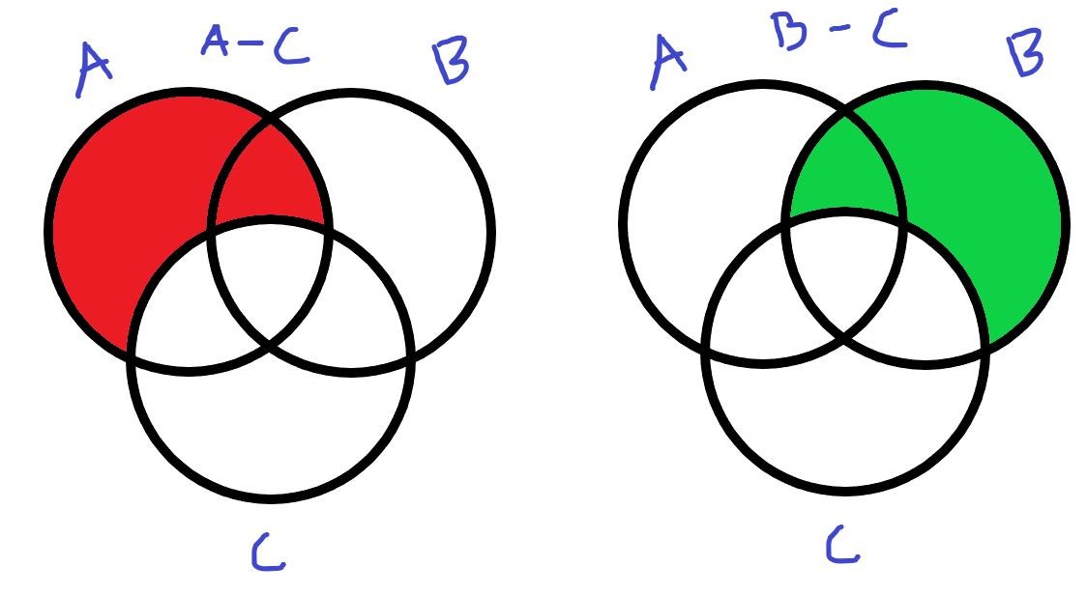

$$\left(A-C\right)=\left\{x | x∈A∧x∉C\right\} \\ \left(B-C\right)=\left\{x | x∈B∧x∉C\right\} \\ \left(A-C\right)∩\left(B-C\right) \\ \left(x∈A∧x∉C\right)∧\left(x∈B∧x∉C\right) \\ \left(x∈A∧x∈\overline{C}\right)∧\left(x∈B∧x∈\overline{C}\right) \\ \left(x∈A∧x∈B\right)∧\left(x∉C∧x∉C\right) \\ \left(x∈A∧x∈B\right)∧\left(T\right) \\ (T)$$

This means that the statement, $\left(A-C\right)∩\left(B-C\right)$, is a set that contains something.

c)

$$f\left(x\right)=x^{2} \\ f:R→R$$

As stated by the book this is the definition of an injective function:

A function $f$ is said to be one-to-one, or an injection, if and only if $f(a)=f(b)$ implies that $a=b$ for all $a$ and $b$ in the domain of $f$.

$$a=2 \\ b=-2 \\ f\left(a\right)=4 \\ f\left(b\right)=4$$

In this instance $f\left(a\right)= f\left(b\right)$, but $a ≠ b$. Which means $f$ is not one-to-one (injective). This also implies f can’t be a one-to-one correspondence (bijective).

Furthermore, the book states:

A function $f$ from $A$ to $B$ is called onto, or a surjection, if and only if for every element $b∈B$ there is an element $a∈A$ with $f(a)=b$.

And since there doesn't exist a single $a$ in $R$ that makes $f(a)=-1$, $f$ isn’t an onto (surjective) function ether.